We All Have a Voice!
Conversation-Changer: ____________________ (name)
1,000 Thank Yous Challenge

Gaudy Goal: Create and Collect 1,000 Thank You notes in 7 Days

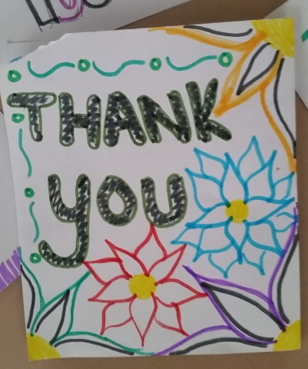
JOIN US in our mission!
Here’s how you can TAKE ACTION to change the conversation:
- Take a piece of paper, any kind!
- CREATE a thank you to a person you know. Color it nicely. : )
- Explain WHY you are thanking this person. This is IMPORTANT. SHARE the reasons.
- Give your Thank You to that person or have it delivered
REPEAT as many times as possible!
4 Simple Steps to YOUR Building a BETTER COMMUNITY
date | name/class | # of Thank Yous | Total

